Table of contents Page
- Scope 1
- Principles 1
- Fence elements 1
Fence nettings 1
Fence posts 2
Fence post elements 2
Fence connecting post PV 4
Fence end post PER 5
Fence end post PEL 6
Fence corner post PR 7
Fence angle post, left, PWL 8
Fence angle post, right, PWR 9
Fence T-post PT 10
- Fastening elements 11
- Cover cap 12
- Fence post units 12
- Materials 13
- Examples of designation 13

Scope
This standard specifies the fence elements used in the NIHVA of fence nettings, posts, fastening elements and cover caps for use in fence systems as specified in SN 401-1.
The fence elements stated herein shall be used for the safety categories T I and T II (see SN 401-1).

Principles
For uniform indication of the dimensions in procurement drawings, the nominal dimensions 1400 and 2200 shall be used as height indications for the individual elements.
Unless otherwise indicated on the manufacturing drawings, the Manufacturing Instructions SN 200 apply to the manufacture of fence elements according to this standard.

Fence elements
Fence element is the general term for all fence nettings and fence posts.

Fence nettings
The protective fence system consists of frameless double-rod wire nettings with wire diameters of 8/6/8 mm (2 bars of 8 mm each in horizontal direction, 1 bar of 6 mm in vertical direction). The mesh width is 200/25 mm (200 mm horizontal spacing and 25 mm vertical spacing, see Fig. 1). To ensure resistance of the fence system against forces acting on it and against environmental influences, the welded fence nettings shall fulfill the requirements specified in DIN EN 10223-7, sections 6 and 7. Table 1 shows the sizes which are relevant for NIHVA. Whenever possible, fence nettings of 1000 and 2000 mm in width shall be used. Intermediate sizes shall be used only as adapting elements.

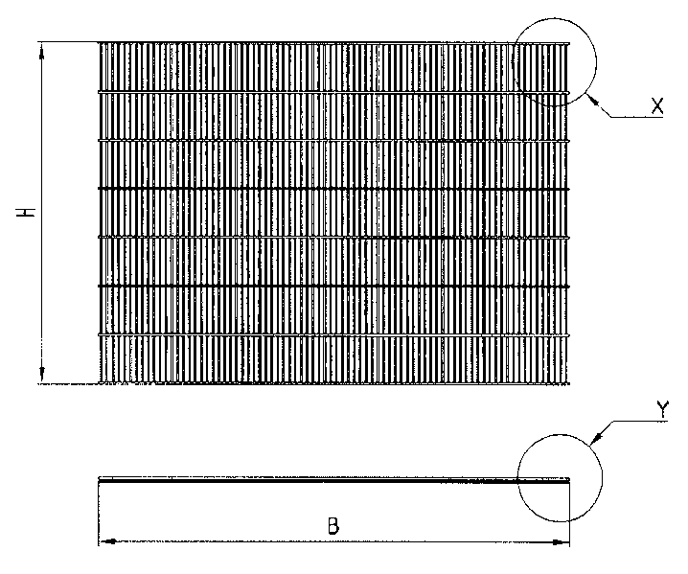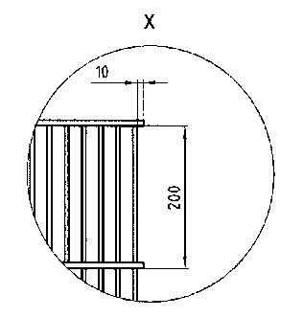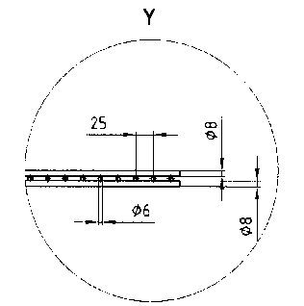
L

Fig. 1 – Fence netting DM Table 1 - Dimensions
Ordering designation a) | Height H | Width L | Weight in kg/unit
SN 401-2 - DM1400x1000 | 1408 | 1000 | 7,98
SN 401-2 - DM-1400x2000 | 1408 | 2000 | 15,96
SN 401-2 - DM-1400 | 1408 | Adapted b) | -
SN 401-2 - DM-2200x1000 | 2208 | 1000 | 12,54
SN 401-2 - DM-2200x2000 | 2208 | 2000 | 25,08
SN 401-2 - DM-2200 | 2208 | Adapted b) | -
a) Nominal dimensions 1400 and 2200
a Given the space requirement of the retaining plates and for reasons of stability, the widths of the fence nettings to be adapted shall be in the range from 300 to 1975 mm and always with spacings of 25 mm.

Fence posts
The fence posts consist of square pipes with welded-on base plates. With the exception of types PR, PWR, PWL and PW, all fence posts are stiffened with gusset plates on the side of the danger zone. The top sides of the posts shall be closed with plastic cover caps, see item 4.
To achieve on fence systems according to SN 401-1 a connection of maximum stability between fence nettings and fence posts, the fence posts are provided with welded-on holding lugs. Fence posts can also be ordered as complete units provided with all necessary fastening elements.

Fence post elements
To allow flexible construction of the fence systems, fence posts are available in various basic types (see figures 2 to 6). The detail views of the different types are shown in the figures 7 to 12. The dimensions are stated in Table 2.

Connecting post between fence elements

Fig. 2 – Type PV
Fig. 3 - Type PE
End post as final element of a fencing, e.g. at a door.

Right-angle corner post for the connection of two fence elements.

Fig. 4 –Type PR

Angle post, right, for the connection of fence elements at an angle of 45°.
Angle post, left, for the connection of fence elements at an angle of 45°.

Fig. 5.1 – Type PWL

T-post for the connection of 3 fence elements at an angle of 90°.

Fig. 5.2 – PWR Fig. 6 - PT

Table 2 – Fence post elements
Type | Ordering designationa) | Height H | Distance C | Distance D | Distance E | Weight kg/unit
 | SN 401-2-PV-1400 | 1410 | 370 | 508 | 380 | 9,94
 | SN 401-2-PER-1400 | 1410 | 370 | 508 | 380 | 9,56
 | SN 401-2-PEL-1400 | 1410 | 370 | 508 | 380 | 9,56
 | SN 401-2-PR-1400 | 1410 | 370 | 508 | 380 | 10,58
 | SN 401-2-PWL-1400 | 1410 | 370 | 508 | 380 | 10,58
 | SN 401-2-PWR-1400 | 1410 | 370 | 508 | 380 | 10,58
 | SN 401-2-PT-1400 | 1410 | 370 | 508 | 380 | 10,96
 | SN 401-2-PV-2200 | 2210 | 570 | 908 | 580 | 14,45
 | SN 401-2-PER-2200 | 2210 | 570 | 908 | 580 | 14,07
 | SN 401-2-PEL-2200 | 2210 | 570 | 908 | 580 | 14,07
 | SN 401-2-PR-2200 | 2210 | 570 | 908 | 580 | 15,09
 | SN 401-2-PWL-2200 | 2210 | 570 | 908 | 580 | 15,09
 | SN 401-2-PWR-2200 | 2210 | 570 | 908 | 580 | 15,09
 | SN 401-2-PT-2200 | 2210 | 570 | 908 | 580 | 15,47
a) Nominal dimensions 1400 and 2200

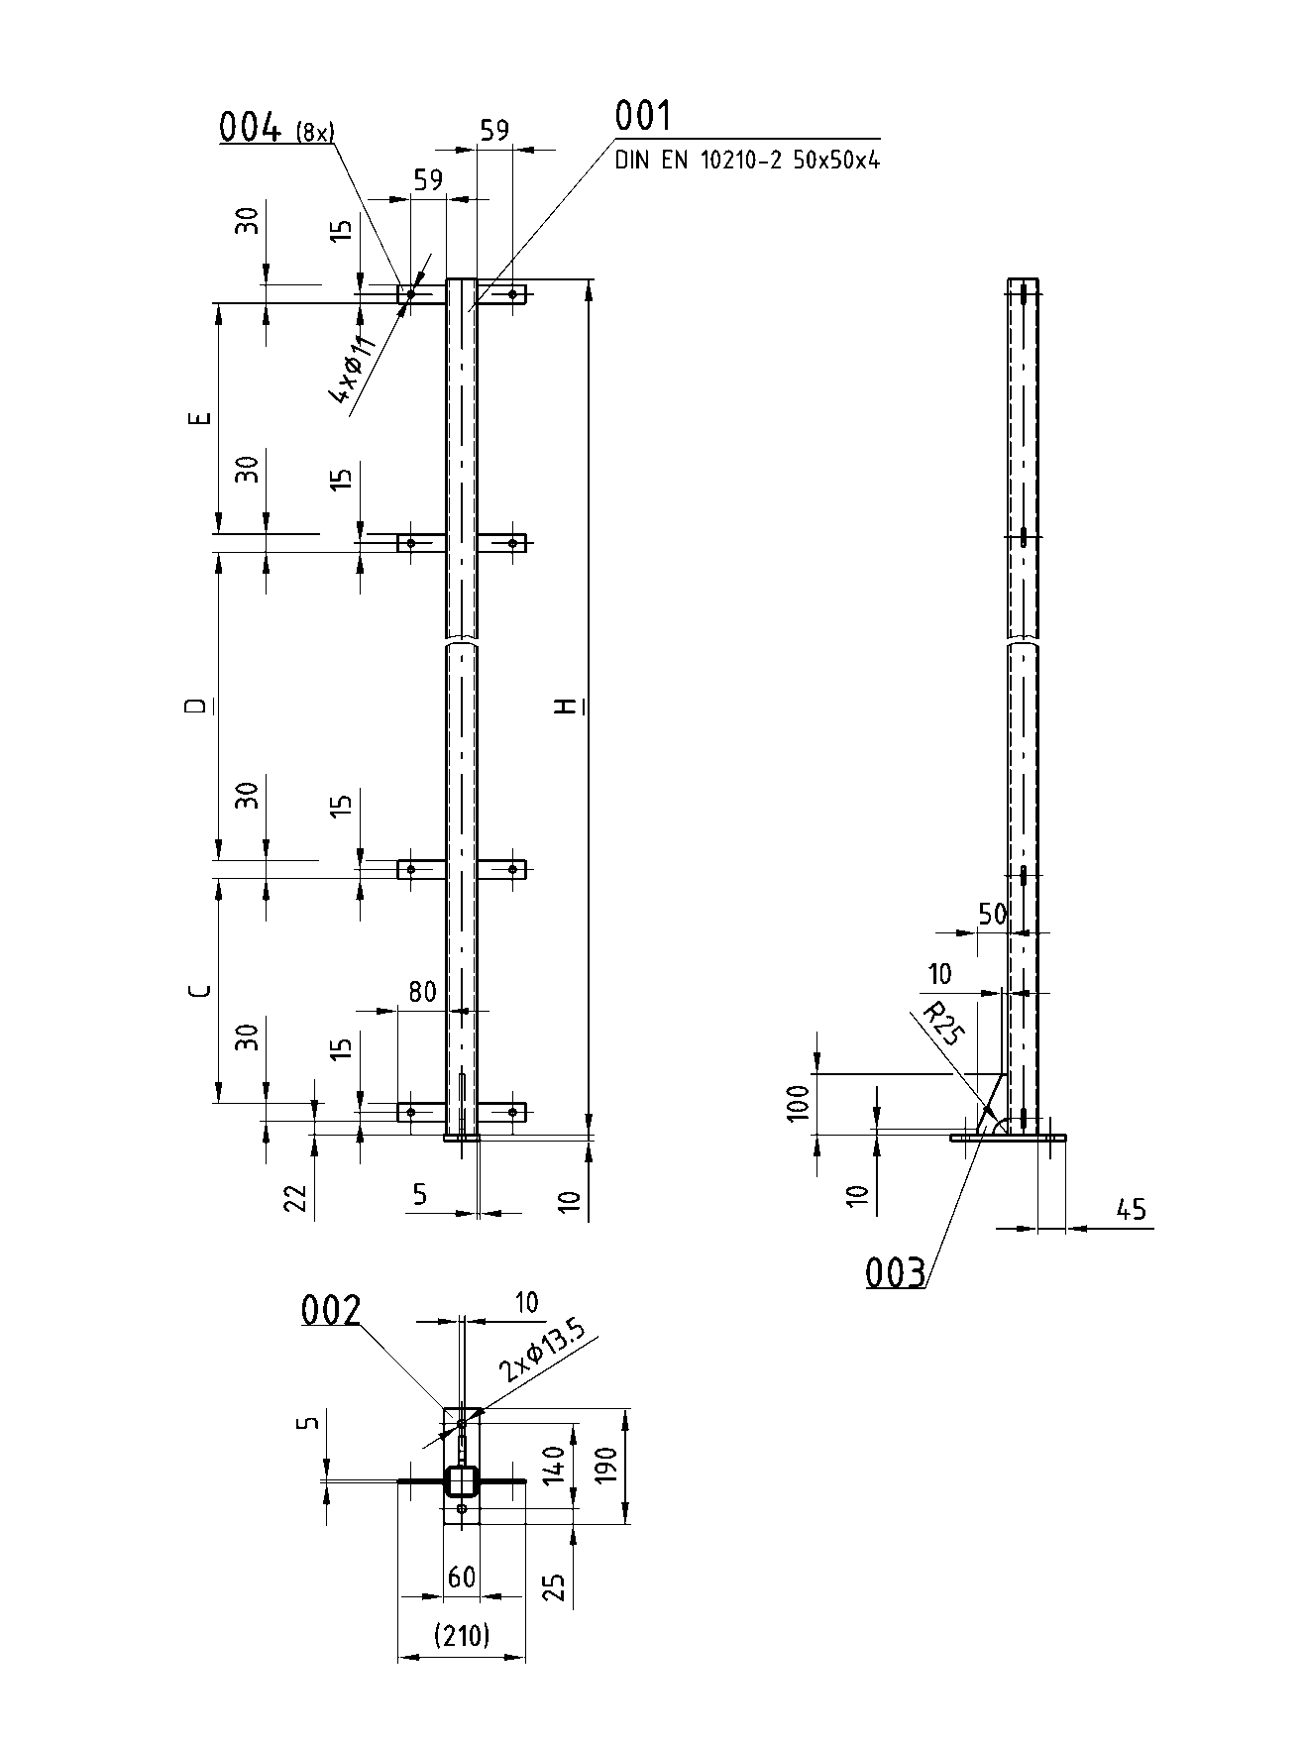Fence connecting post PV

Fig. 7 – Fence connecting post PV

Fence end post PER

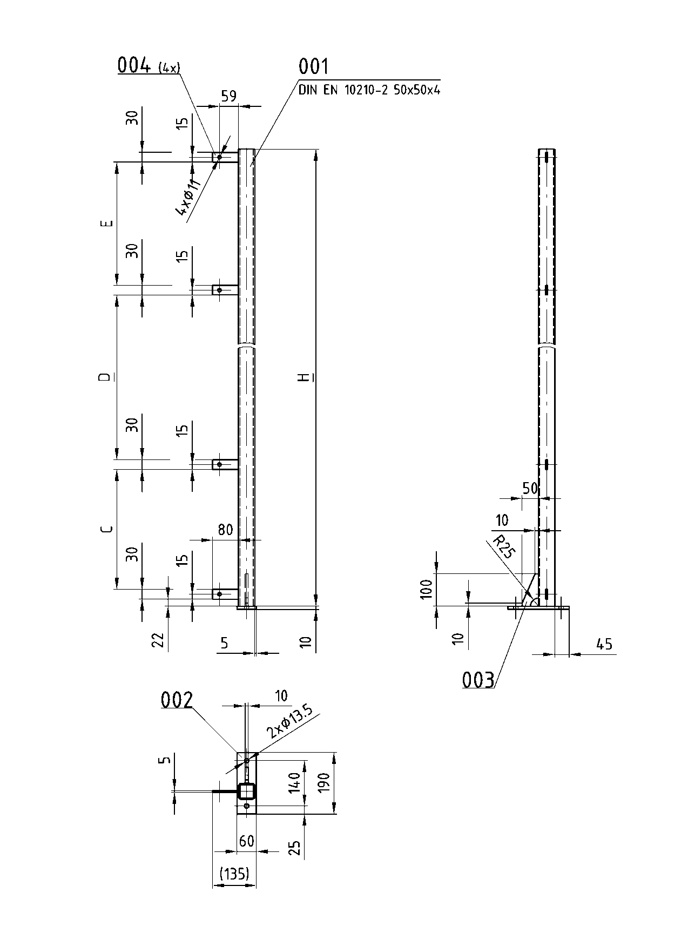
Fig. 8 – Fence end post PER

Fence end post PEL

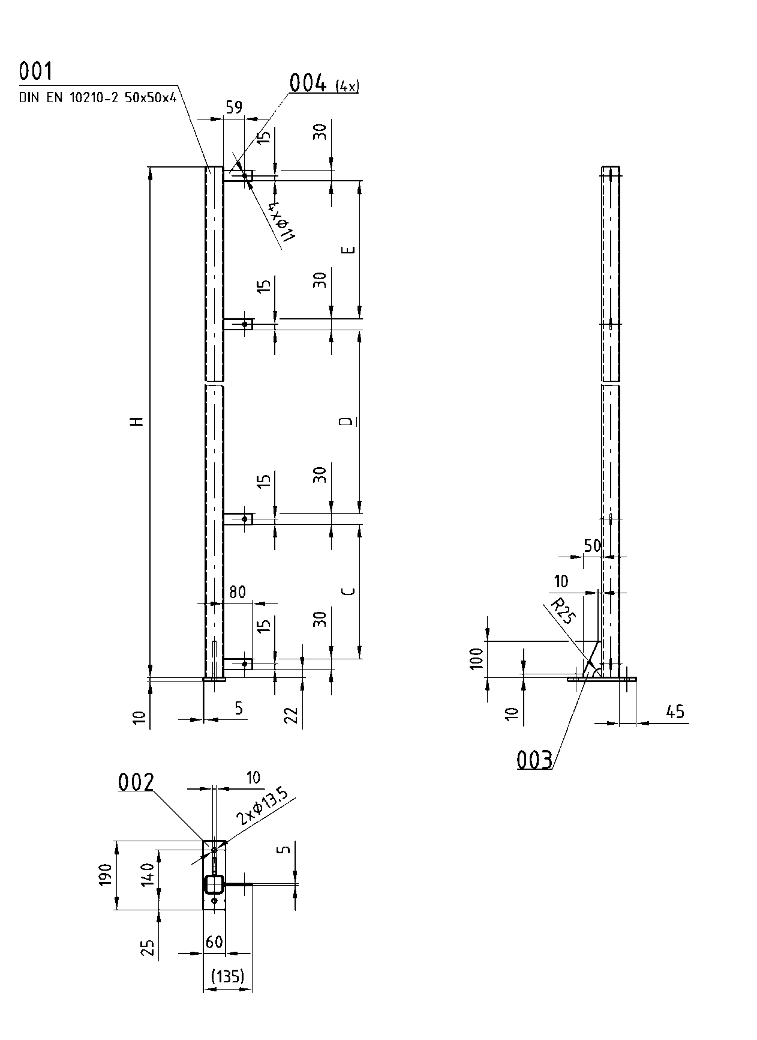

Fig. 9 – Fence end post PEL

Fence corner post PR

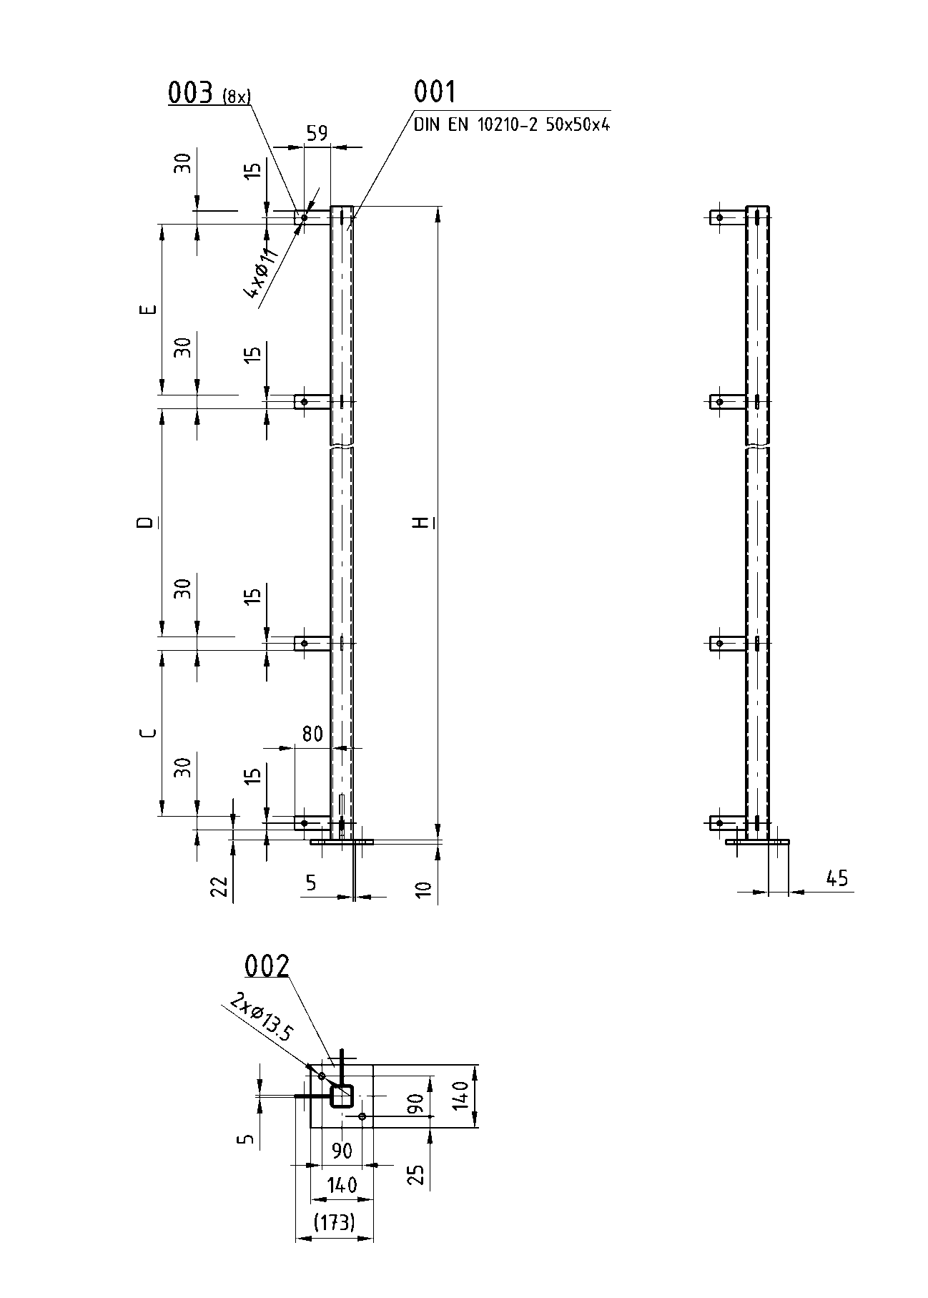

Fig. 10 – Fence corner post PR

Fence angle post, left, PWL

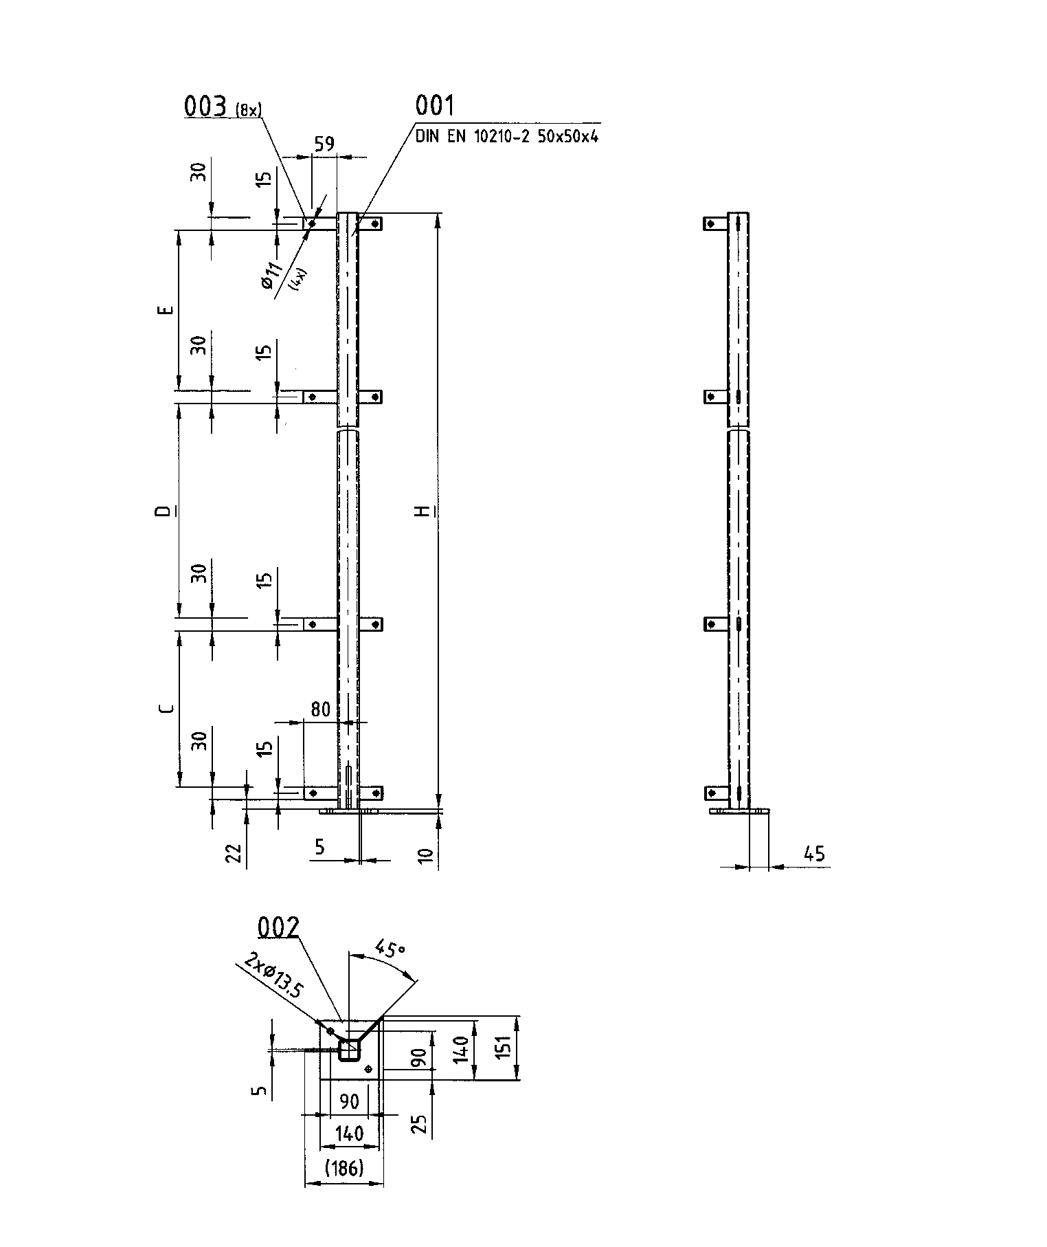

Fig. 11 – Fence angle post, left, PWL

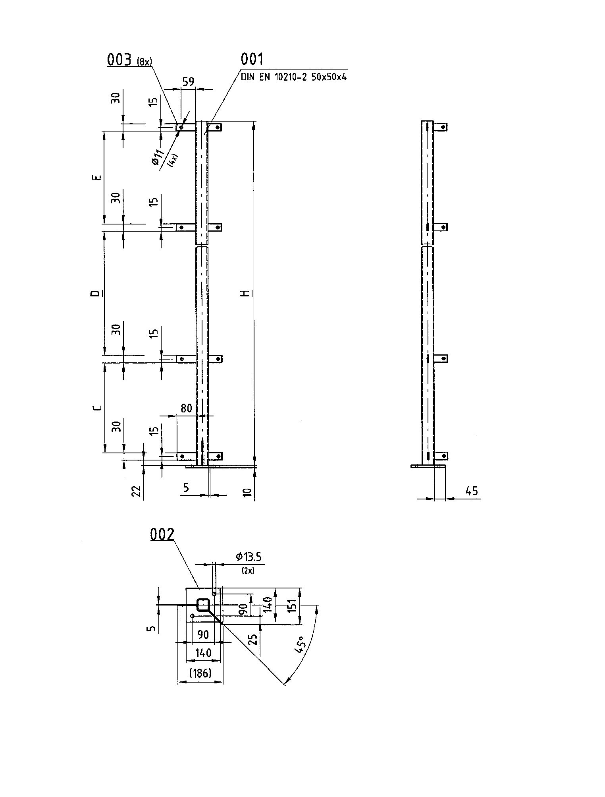

Fence angle post, right, PWR

Fig. 12 – Fence angle post, right, PWR

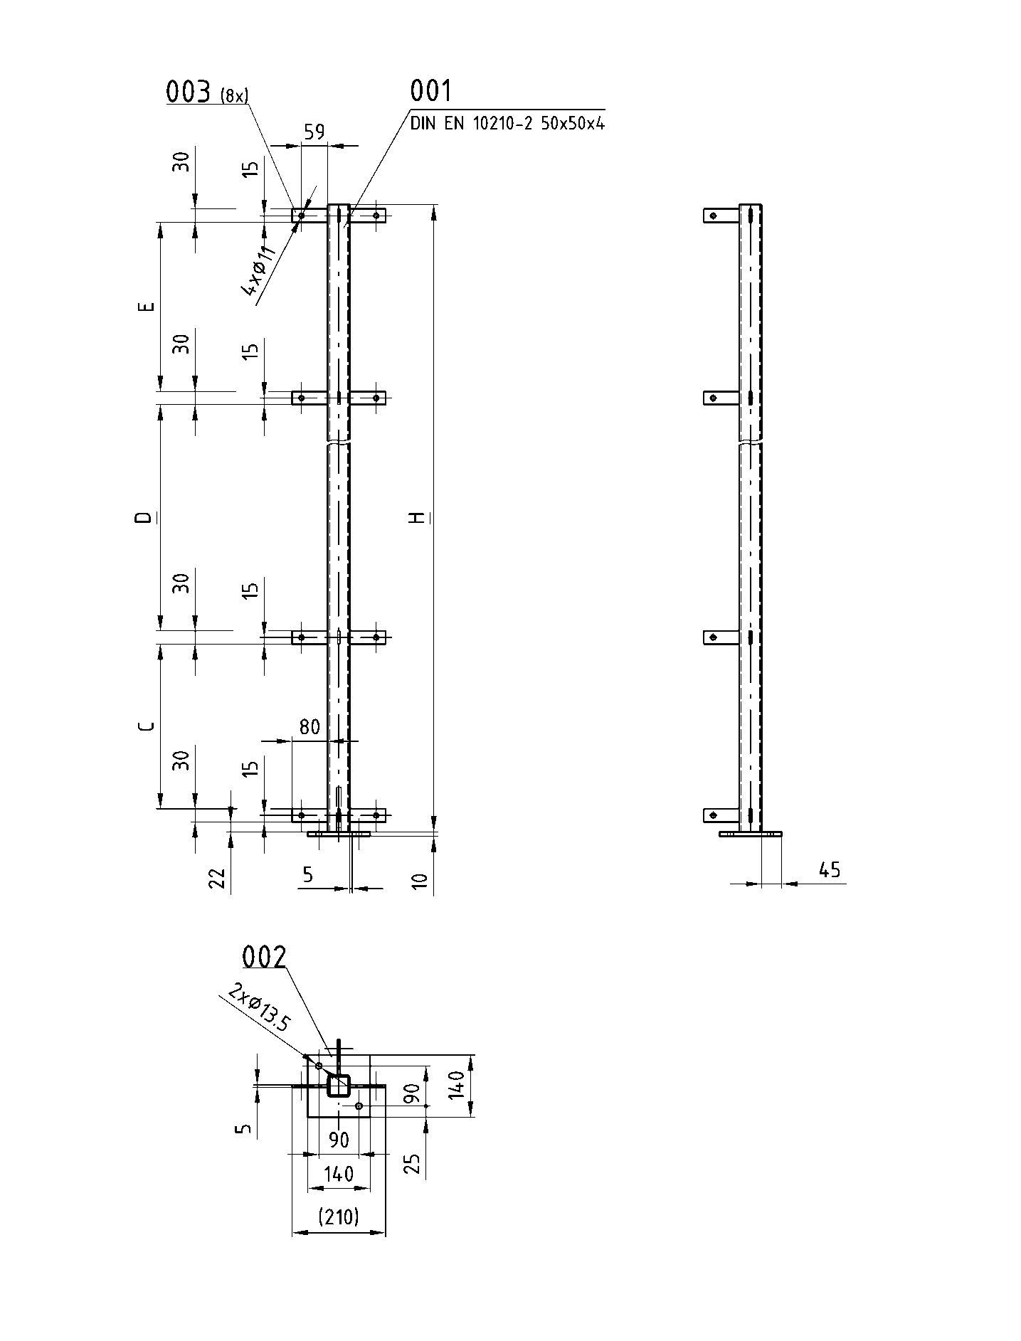Fence T-post PT

Fig. 13 - Fence T-post PT

Fastening elements
The fence and door posts are fastened in the floor with stud anchors available as catalogue parts according to Table 3. The fence nettings are fastened to the posts with prefabricated retaining plates and mushroom-head square neck bolts (see figures 14 and 15) to prevent loosening of the connection from outside.
The fastening elements are shown in Table 3.
Welding up of fence elements during assembling or other ways of fastening are not allowed.

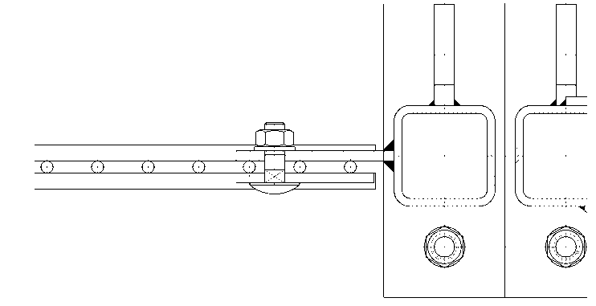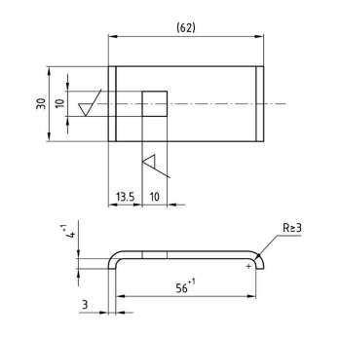

Fig. 14- Fastening Fig. 15 - Retaining plate HB

Table 3 – Fastening elements for fence systems
Designation | Ordering indication | Material indication for fence system made of  S235JR a) | Material indication for fence system made of  X5CrNi18-10 (1.4301) | Weight kg/unit
Retaining plate | SN 401-2 - HB | S235JR | X5CrNi18-10 (1.4301) | 0,075
Stud anchor | HILTI - HST- M12x115/20 | St GLVZ | - | 0,150
Stud anchor | HILTI - HST- HCR - M12x115/20 | - | X1NiCrMoCuN25-20-7 (1.4529) | 0,150
Mushroom-head square neck bolt | DIN 603 - M10x30 | 8.8 A0U | A2-70 | 0,025
Washer | ISO 7089 -10 | ST-HV200 | A2-200 | 0,004
Hexagon nut | ISO 4032 - M10 | 8 A0U | A2-70 | 0,012
a) Fence system made of S235JR (with subsequent powder coating) or S235JR TZN

Cover cap
To protect the posts in rough ambient conditions, every fence and door post according to SN 401-2 and 401-3 shall be provided with protective plastic cover (Fig. 16) at the top side. The design of the inner part of the cap is at the maker's choice and shall be suitable for pipe wall thicknesses of 4 to 6,3 mm. Data of the cover cap are shown in Table 4.

Table 4 – Cover cap
Designation | Ordering indication | Material a) | Colour | Weight kg/unit
Cover cap | SN 401-2 - AK | PE | Black | 0,025
a Cover caps are always made of PE irrespective of the fence system material.

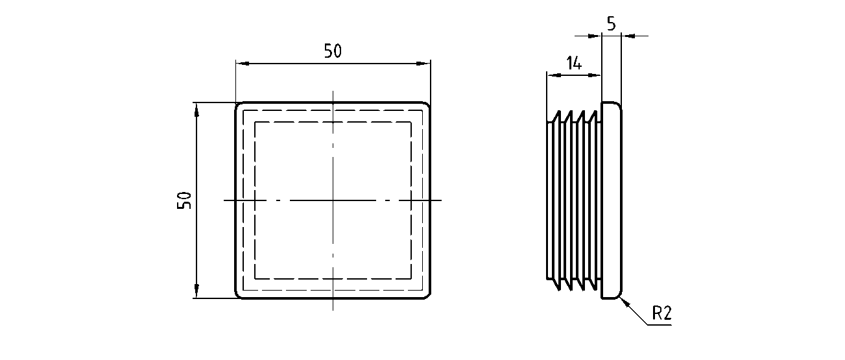
Fig. 16 – Cover cap AK

Fence post units
All fence posts stated in Table 2 can also be ordered as complete units in the material required and with all pertaining fastening elements and cover cap. To indicate the complete unit, the letter "E" shall precede the ordering indication of the respective fence post. Table 5 shows the bill of materials for a complete fence post unit as an example.

Table 5 – Bill of materials (example)
Quantity | Designation
1 | Fence post unit SN 401-2-EPR-2200-X5CrNi18-10
Consisting of:
1 | Fence corner post SN 401-2 – PR – 2200 - X5CrNi18-10
1 | Cover cap SN 401-2 - AK - PE
8 | Retaining plate SN 401-2 - HB - X5CrNi18-10
8 | Mushroom-head square neck bolt DIN 603-M10x30 - A2-70
8 | Washer ISO 7089 – 10 St-HV200 - A2-200
8 | Hexagon nut DIN EN ISO 4032 - M10 - A2-70
2 | Stud anchor HILTI - HST - HCR - M12x115/20 - 1.4529

Materials
8 A0U according to DIN EN ISO 898-6, galvanised
8.8 A0U according to DIN EN ISO 898-1, galvanised
A2-70 according to DIN EN ISO 3506-1
A2-200 according to DIN EN ISO 3506-1
PE according to DIN EN ISO 1043-1, polyethylene
S235JR according to DIN EN 10025-2, structural steel, surface untreated (for subsequent powder coating)
S235JR TZN according to DIN EN 10025-2, structural steel, surface galvanised,
St GLVZ steel, electrogalvanised
X1NiCrMoCuN25-20-7 (1.4529) according to DIN EN 10028-7, austenitic stainless steel, without surface treatment. X5CrNi18-10 (1.4301) according to DIN EN 10088-3, austenitic stainless steel, without surface treatment.

8 Examples of designation

Designation of a fence netting with 1400 mm nominal height, 1000 mm long, made of galvanised structural steel:

Fence netting SN 401-2-DM-1400x1000-S235JR-TZN

Designation of an adapted fence netting 1375 mm long, nominal height 2200 mm, made of X5CrNi18-10 (1.4301):

1375 mm fence netting SN 401-2-DM-2200-X5CrNi18-10

Designation of an angle fence post with 1400 mm nominal height, made of structural steel, untreated:

Fence post SN 401-2-PW-1400-S235JR

Designation of a fence end-post unit for left end, 2200 mm nominal height, and made of galvanised structural steel:

Fence end post unit SN 401-2-EPEL-2200-S235JR+N TZN

Designation of a cover cap:

Cover cap SN 401-2-AK

Referenced technical standards, codes and regulations

DIN 603 Cup head square neck bolts
DIN EN 10025-2:2005-04 Hot rolled products of structural steels - Part 2: General technical delivery conditions for non-alloy structural steels
DIN EN 10028-7:2008-02 Flat products made of steels for pressure purposes - Part 7: Stainless steels
DIN EN 10088-3:2005-09 Stainless steels - Part 3: Technical delivery conditions for semi-finished products, bars, rods, wire, sections and bright products of corrosion-resisting steels for general purposes
DIN EN 10210-2 Hot finished structural hollow sections of non-alloy and fine grain steels -
Part 2: Tolerances, dimensions and sectional properties DIN EN 10223-7 Steel wire and wire products for fencing and netting -
Part 7: Steel wire welded panels for fencing
DIN EN ISO 898-1 Mechanical properties of fasteners made of carbon steel and alloy steel - Part 1: Bolts, screws and studs with specified property classes - Coarse thread and fine pitch thread
DIN EN ISO 898-6 Mechanical properties of fasteners -
Part 6: Nuts with specified proof load values; Fine pitch thread DIN EN ISO 1043-1 Plastics - Symbols and abbreviated terms -
Part 1: Basic polymers and their special characteristics
DIN EN ISO 3506-1 Mechanical properties of corrosion-resistant stainless steel fasteners -
Part 1: Bolts, screws and studs
DIN EN ISO 4032 Hexagon nuts, style 1 - Product grades A and B DIN EN ISO 7089 Plain washers - Normal series, product grade A SN 200 Manufacturing Instructions
SN 401-1:2011-08 Safety provisions for danger zones; Fence systems; Overview - Definitions SN 401-3:2013-04 Safety provisions for danger zones; Door units and door elements

